**How many businesses have tot_success of at least two? What percentage is that of the entire data set?**

d = ( tot_success >=2/total number of data )*100

= (66/200)*100 = 33%

**How many businesses have two or more occurrences of non-success(Total_nsuccess)? What percentage is that of the entire data set?**

f = (total_nsuccess>=2/total number of data)*100

= (38/200)*100 = 19%

1. Assuming previous success [1,0], what is the probability of having a successful year?

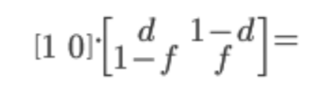

> mat1<- matrix(c(1,0), 1, byrow = T)

> mat2 <- matrix(c(.33, .67, .81, .19), 2, byrow = T)

> matsol <- mat1 %*% (mat2 %^% 1)

> matsol

[,1] [,2]

[1,] 0.33 0.67

1. What is the probability of having two successful years?

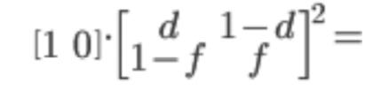

> mat1<- matrix(c(1,0), 1, byrow = T)

> mat2 <- matrix(c(.33, .67, .81, .19), 2, byrow = T)

> matsol1 <- mat1 %*% (mat2 %^% 2)

> matsol1

[,1] [,2]

[1,] 0.6516 0.3484

1. Using the strategy outlined in the document “How to iterate Markov Processes in R, “ show the table of values for 10 years of success:

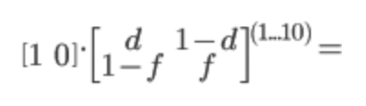

> xrez <- NULL

> for(x in 1:10){

+ xrez <- c(xrez, mat1 %*% ( mat2 %^% x))

+ }

> matrez <- matrix(xrez, 10, byrow = T)

> print(matrez)

[,1] [,2]

[1,] 0.3300000 0.6700000

[2,] 0.6516000 0.3484000

[3,] 0.4972320 0.5027680

[4,] 0.5713286 0.4286714

[5,] 0.5357623 0.4642377

[6,] 0.5528341 0.4471659

[7,] 0.5446396 0.4553604

[8,] 0.5485730 0.4514270

[9,] 0.5466850 0.4533150

[10,] 0.5475912 0.4524088

1. Using the success and 1 – success matric output from problem 3, produce a line graph in Excel showing how the probabilities stabilize over time. It will look something like this:

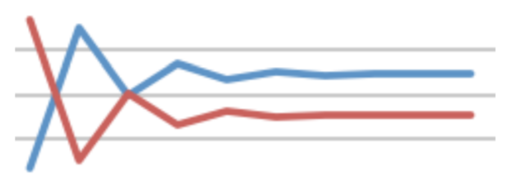



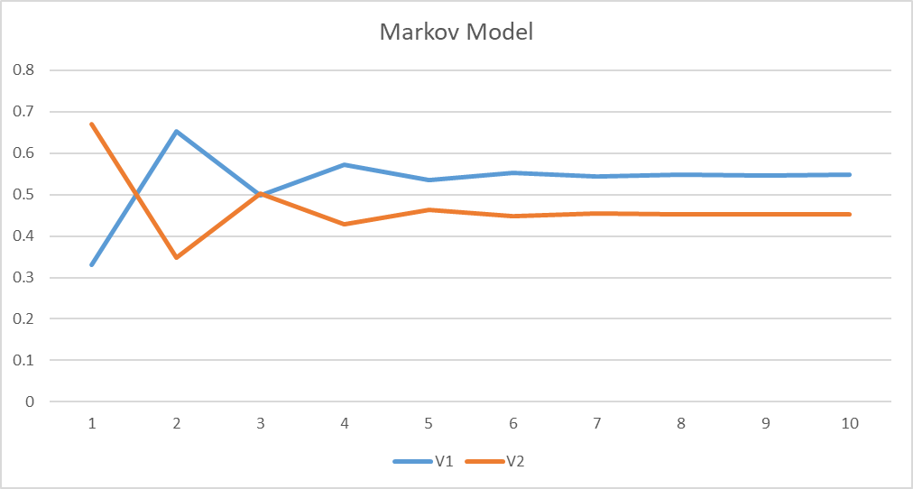

1. At the end of 10 years, what are values of the blue and red lines? These are your new X% and 1-X% in the tree model. These represent the long-term probability of success or non-success, given the starting state of a business.

X% = 54.75912%

1-X% = 45.24088%

After replacing the X and 1- X values with the new values. The values of cells which is dependent on those X and 1- X values also changes.

|  |  |  |  |  |
| --- | --- | --- | --- | --- |
| **Biz 51** | **Dustin's research** |  |  |  |
|  | positive (YR) | negative (NR) | MARGINAL PROB |  |
| Viable (YV) | P(YV&YR) | P(YV&NR) | P(YV) |  |
| Not viable (NV) | P(NV&YR) | P(NV&NR) | P(NV) |  |
| MARGINAL PROB | P(YR) | P(NR) | 1 |  |
|  |  |  |  |  |
| ***[ANSWERS:]*** |  |  |  |  |
|  | positive (YR) | negative (NR) | MARGINAL PROB |  |
| Viable (YV) | 32.9% | 21.9% | 55% | ***Success*** |
| Not viable (NV) | 13.6% | 31.7% | 45% | ***1-Success*** |
| MARGINAL PROB | 46.4% | 53.6% | 1 |  |
|  |  |  |  |  |
| P(YR|YV)= | 60% | P(NR|YV)= | 40% |  |
| P(YR|NV)= | 30% | P(NR|NV)= | 70% |  |
|  |  |  |  |  |
| **Conditional Probabilities:** |  |  |  |  |
| P(YV|YR)= | **70.8%** | P(NV|YR)= | 29.2% |  |
| P(YV|NR)= | 40.9% | P(NV|NR)= | 59.1% |  |

1. Should you employ Dustin to do the research or not? State the new EVs and Explain your decision and what the tree is telling you. Use the new X% and 1-X% in your problemset 10 tree model in Excel and recalculate the tree.

Actual Probability values:

|  |  |  |  |  |
| --- | --- | --- | --- | --- |
| **Biz 51** | **Dustin's research** |  |  |  |
|  | positive (YR) | negative (NR) | MARGINAL PROB |  |
| Viable (YV) | P(YV&YR) | P(YV&NR) | P(YV) |  |
| Not viable (NV) | P(NV&YR) | P(NV&NR) | P(NV) |  |
| MARGINAL PROB | P(YR) | P(NR) | 1 |  |
|  |  |  |  |  |
| ***[ANSWERS:]*** |  |  |  |  |
|  | positive (YR) | negative (NR) | MARGINAL PROB |  |
| Viable (YV) | 35.4% | 23.6% | 59% | ***Success*** |
| Not viable (NV) | 12.3% | 28.7% | 41% | ***1-Success*** |
| MARGINAL PROB | 47.7% | 52.3% | 1 |  |
|  |  |  |  |  |
| P(YR|YV)= | 60% | P(NR|YV)= | 40% |  |
| P(YR|NV)= | 30% | P(NR|NV)= | 70% |  |
|  |  |  |  |  |
| **Conditional Probabilities:** |  |  |  |  |
| P(YV|YR)= | **74.2%** | P(NV|YR)= | 25.8% |  |
| P(YV|NR)= | 45.1% | P(NV|NR)= | 54.9% |  |



This tree says that we don’t need any research based on the EV values. That the optimum strategy of the company to follow which is no research need and decide to buy and then that decision makes the companies to reach the expected potential payouts.

After changing those X and 1- X values the tree has changed. Yes, Dustin should be employed to do the research. Because of X and 1- X is the EVs also changes and based on these EVs the new optimum strategy is doing research and that research should be a positive research and then decided to buy and that decision is working and we get the potential payouts.

|  |  |  |  |  |
| --- | --- | --- | --- | --- |
| **Biz 51** | **Dustin's research** |  |  |  |
|  | positive (YR) | negative (NR) | MARGINAL PROB |  |
| Viable (YV) | P(YV&YR) | P(YV&NR) | P(YV) |  |
| Not viable (NV) | P(NV&YR) | P(NV&NR) | P(NV) |  |
| MARGINAL PROB | P(YR) | P(NR) | 1 |  |
|  |  |  |  |  |
| ***[ANSWERS:]*** |  |  |  |  |
|  | positive (YR) | negative (NR) | MARGINAL PROB |  |
| Viable (YV) | 32.9% | 21.9% | 55% | ***Success*** |
| Not viable (NV) | 13.6% | 31.7% | 45% | ***1-Success*** |
| MARGINAL PROB | 46.4% | 53.6% | 1 |  |
|  |  |  |  |  |
| P(YR|YV)= | 60% | P(NR|YV)= | 40% |  |
| P(YR|NV)= | 30% | P(NR|NV)= | 70% |  |
|  |  |  |  |  |
| **Conditional Probabilities:** |  |  |  |  |
| P(YV|YR)= | **70.8%** | P(NV|YR)= | 29.2% |  |
| P(YV|NR)= | 40.9% | P(NV|NR)= | 59.1% |  |

